Spy Spotting Scope
Student Edition
Name: | Subject(s)/Course(s): Physical Science |  |  | Date:
Synopsis and Narrative::
Spotting scopes area class of small portable telescopes that are optimized for observation of terrestrial objects. They are commonly used for hunting, marksman sports, surveillance, and other naturalist activities when the application requires more magnification than a pair of binoculars.
Challenging Question or Problem:
How can we create a spotting scope to spy on small objects across the room?
Open Question: What is the minimum spy spotting scope focal length required to optically resolve the license plate on an oncoming car that is 1,000 meters away using the image sensor on your cell phone. (camera without the lens)
Phenomenon and Manufacturing Application:
Optimax or QED Optics. Any optics company that manufactures lenses for spotting scope applications.
Examples (in action):  U.S. Army Spc. Zachary Dixson, with the 173rd Airborne Brigade Combat Team uses a spotting scope to watch for simulated enemy combatants during an exercise at the Joint Multinational Readiness Center in Hohenfels, Germany, on March 21, 2012.  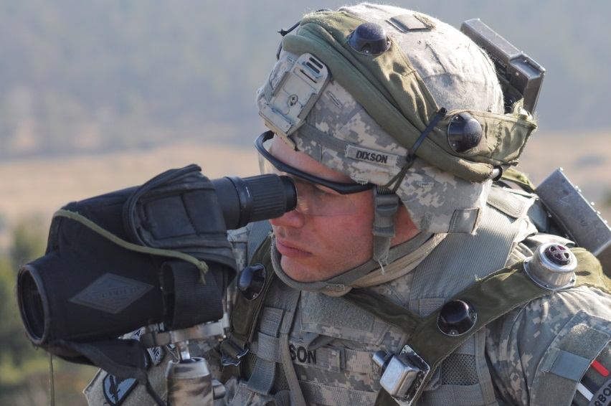  Defense.gov News Photo 120321-A-ML570-006 Author Sgt. Eric M. Garland II, U.S. Army |  |  | Vocabulary:  Lens  Convex  Focal point  Focal length  Principal axis  Real image  Virtual image
State and National Standards & 21st Century Skills:
Use mathematical models to determine relationships among the size and location of images, size and location of objects, and focal lengths of lenses and mirrors. Emphasis should be on analyzing ray diagrams to determine image size and location. Assessment Boundary: Assessment is limited to analysis of plane, convex, and concave mirrors, and biconvex and biconcave lenses.
Materials and Equipment:
1, 50mm, f=50mm convex lens
1, 50mm, f=100mm convex lens
1, 50mm, f=100mm concave lens
1, 50mm, f=200mm concave lens
1, 50mm, f=200mm convex lens
1, 50mm, f=300mm convex lens
1, 50mm, f=300mm concave lens
1, 50mm, f=500mm convex lens

1 optical tube assembly
2 laser blox (color ultimately does not matter but red and green is safer)
Fog Machine (only if the activity is performed outside or in a room with heat detectors. DO NOT use fog machine in a room with smoke detectors).

Materials not provided in kit:
1, metric ruler
Blank paper
Poster paper or receipt paper
Markers
Safety:
NEVER point the spotting scope towards the sun, never look at the sun with the spotting scope. Doing so can cause burns, permanent eye damage, or property damage.

Lasers are light sources that can permanently damage the eye. They are not toys. If you stare into a laser beam for a period of time, permanent and irreparable damage to the eye can occur. The Laser Blox set provided in the kit is a Class IIIR laser product. At this power rating the human eye blink reflex will prevent any permanent eye damage. To reduce the chance of eye injury, do not completely darken the room as to prevent complete pupil dilation.
Learning Targets:
Convex and concave lenses form real and virtual images and how lenses can be paired to magnify images.
Draw and analyze ray diagrams to determine image size and location.

Introduction/Warmup: The history of telescopes
Who Invented the Telescope?
By Lauren Cox, SPACE.com Contributor | July 13, 2013 11:40am ET

The telescope is one of humankind's most important inventions. The simple device that made far away things look near gave observers a new perspective. When curious men pointed the spyglass toward the sky, our view of Earth and our place in the universe changed forever.

But who invented the telescope? The answer remains a mystery today. It is highly probable that as glassmaking and lens-grinding techniques improved in the late 1500s, someone held up two lenses and discovered what they could do.
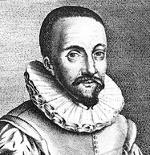
The first person to apply for a patent for a telescope was a Dutch eyeglass maker named Hans Lippershey (or Lipperhey). In 1608, Lippershey tried to lay claim on a device with three-times magnification. His telescope had a concave eyepiece aligned with a convex objective lens. One story goes that he got the idea for his design after observing two children in his shop holding up two lenses that made a distant weather vane appear close. Others charged at the time that he stole the design from another eyeglass maker, Zacharias Jansen.

Jansen and Lippershey lived in the same town and both worked on making optical instruments. Scholars generally argue, however, that there is no real evidence that Lippershey did not develop his telescope independently. Lippershey, therefore, gets the credit for the telescope, because of the patent application, while Jansen is credited with inventing the compound microscope. Both appear to have contributed to the development of both instruments.
Hans Lippershey, credited with invention of the telescope.
Credit: Public domain

Compounding the confusion, yet another Dutchman, Jacob Metius, applied for a patent for a telescope a few weeks after Lippershey. The government of the Netherlands eventually turned down both applications because of the counterclaims. Also, officials said, the device was easy to reproduce, making it difficult to patent. In the end, Metius got a small reward, but the government paid Lippershey a handsome fee to make copies of his telescope.
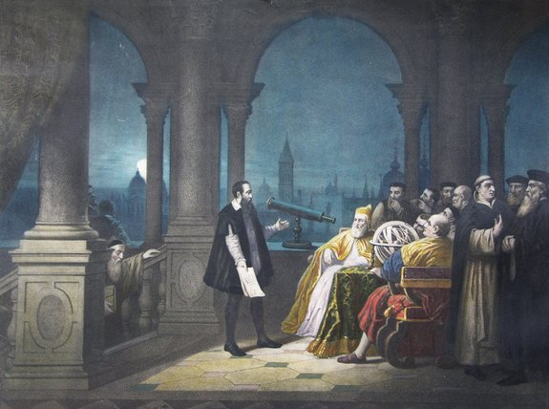
Enter Galileo
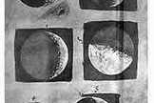
In 1609, Galileo Galilei heard about the "Dutch perspective glasses" and within days had designed one of his own — without ever seeing one. He made some improvements on his initial design and presented his device to the Venetian Senate. The Senate, in turn, set him up for life as a lecturer at the University of Padua and doubled his salary, according to Stillman Drake in his book "Galileo at Work: His Scientific Biography" (Courier Dover Publications, 2003).

Galileo was the first to point a telescope skyward. He was able to make out mountains and craters on the moon, as well as a ribbon of diffuse light arching across the sky — the Milky Way. He also discovered the sun had sunspots, and Jupiter had its own set of moons.
A 1754 painting by H.J. Detouche shows Galileo Galilei displaying his telescope to Leonardo Donato and the Venetian Senate.
Credit: Public domain
Galileo's ink renderings of the moon: the first telescopic observations of a celestial object.
Credit: NASA

The British ethnographer and mathematician Thomas Harriot also used a spyglass to observe the moon. Harriot became famous for his travels to the early settlements in Virginia to detail resources there. His August 1609 drawings of the moon predate Galileo's, but were never published.

The more he looked, the more Galileo was convinced of the sun-centered Copernican model of the planets. Galileo wrote a book “Dialogue Concerning the Two Chief World Systems, Ptolemaic and Copernican” and dedicated it to the Pope Urban VIII. But his ideas were considered heretical, and Galileo was called to appear before the inquisition in Rome in 1633. He struck a plea bargain and was sentenced to house arrest where he continued to work and write until his death in 1642.

Elsewhere in Europe, scientists began improving the telescope. Johannes Kepler studied the optics and designed a telescope with two convex lenses, which made the images appear upside down. Working from Kepler's writings, Isaac Newton reasoned it was better to make a telescope out of mirrors rather than lenses and built his famous reflecting telescope in 1668. Centuries later the reflecting telescope would dominate astronomy.

Exploring the cosmos
The largest refracting telescope ever built opened at Yerkes Observatory in Williams Bay, Wis., in 1897. But the 40-inch wide glass lens at Yerkes was soon made obsolete by larger mirrors. The Hooker 100-inch reflecting telescope opened in 1917 at Mount Wilson Observatory in Pasadena, Calif. It was there that the astronomer Edwin Hubble determined the distance of the Andromeda Nebula — far beyond the Milky Way.
With the development of the radio, scientists could start to study not just light, but other electromagnetic radiation in space. An American engineer named Karl Jansky was the first to detect radio radiation from space in 1931. He found a source of radio interference from the center of the Milky Way. Radio telescopes have since mapped the shape of galaxies and the existence of background microwave radiation that confirmed a prediction in the Big Bang Theory.

In April 1990, the Hubble Space Telescope sailed into orbit. The reflecting telescope took advantage of digital cameras and satellite communications to give jaw dropping views of space free from the interference of the earth's atmosphere and light pollution. More than 200 years after Galileo pointed his telescope skyward, people could see space from the heavens.
Analysis Questions:
- What was Lippershey’s specific contribution to the invention of the telescope?
__________________________________________________________________________________________
__________________________________________________________________________________________

- How did the earliest telescopes work?
__________________________________________________________________________________________
__________________________________________________________________________________________
__________________________________________________________________________________________

- How did Galileo change the course of history with the telescope?
__________________________________________________________________________________________
__________________________________________________________________________________________
__________________________________________________________________________________________
__________________________________________________________________________________________

- What are some important discoveries that telescopes have aided in the past century?
__________________________________________________________________________________________
__________________________________________________________________________________________
__________________________________________________________________________________________
__________________________________________________________________________________________

Part A: Review Convex Lenses
First Lens:
Using the two lasers stacked on top of each other and the 50mm convex lens, place the lens in the tube holder and aligning the lasers to the principle axis, turns the lasers on and investigate how the light bends when it passes through the lens. Refer to the lens color key to identify the lens.

Laser Safety: Lasers are light sources that can permanently damage the eye. They are not toys. When you are not using the laser, TURN IT OFF. Do not let the laser beam wander around the room. Always keep the laser beam below the chest area of all people in the room. Never look into the laser beam or at laser light reflected off of a shiny surface. If you stare into a laser beam for a period of time, permanent and irreparable damage to the eye can occur.

Using the two lasers, investigate how the light bends when the laser light passes through the lens. Place your finger or a small piece of paper or Post-it® note into the path of the laser and observe the location of the laser at a point. Move your finger or the piece of paper towards the lens and then away. Using this method, along with a ruler, verify the focal length this lens, record your results below.

Focal Length:
Convex f₁ = 50mm

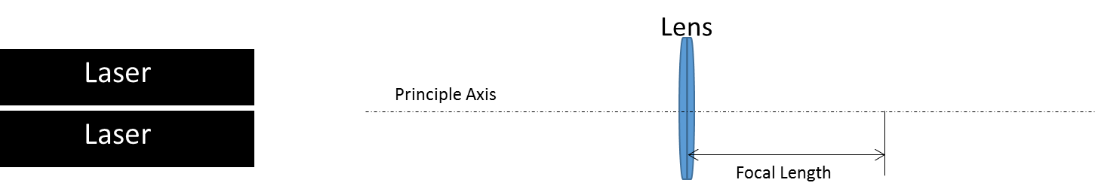
Draw the path of the laser as it refracts through the lens in the box below. This is known as a ray diagram.

Images from Lenses: Lenses bend the light to manipulate an image. Convex lenses can form real or virtual images. We will first explore how real images are formed with theses lenses.

Real images are formed when the object that is creating the image is further from the lens than the focal point of the lens.

Locating images through ray tracing.
We can locate the image of an object as it pertains to the lens by following three rules (see figure 1 below)
- A ray coming from the object that is parallel to the principle axis of the lens will pass through the focal point on the opposite side of the lens. (see ray 1 in figure 1).
- A ray coming from the object that passes through the center of the lens will not experience any change in direction. (see ray 2 in figure 1).
- A ray coming from the object that passes through the focal point on the same side of the lens will emerge from the lens parallel to the principle axis. (see ray 3 in figure 1).

The location of the image is where all three of the rays converge. The size, orientation, and location of the image can be determined from this point (see the figure below 1).

In the area below, create a scale drawing that shows the location, size, and orientation of the image for an object that is 1.5cm tall and 15cm away for the 50mm focal length convex lens (use the receipt paper if you need to).

Figure 1:
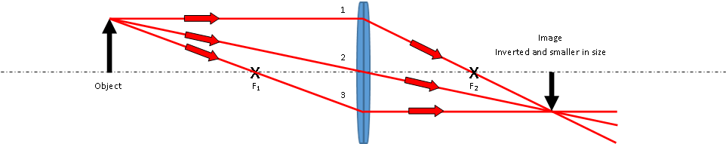

Determine the height of the image (show all work below).

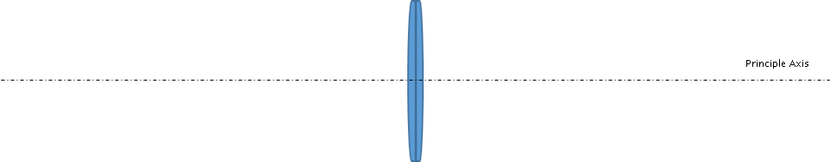

Constructing a Traditional Refracting (Astronomical) Telescope
Research the construction of a traditional refracting telescope.
You will be given a 300mm lens in addition to the 50mm lens you should already have. Determine which lens needs to be the objective and which lens needs to be the eyepiece and how far apart to place them.

Objective lens focal length = _______mm
Eyepiece lens focal length = _______mm
Distance between lenses = _______mm

- What is the difference in optical design between a microscope and a telescope? (cite your source)

________________________________________________________________________________________________________________________________________________________________________________________________________________________________________________________________________________________________________________________________________________________________________

- Place the lenses in the optical tube assembly at the proper distances and assemble the tube by carefully placing the second half on top and securing it with the end stops.

- Observe an object that is at infinite focus or far away. NEVER point the spotting scope towards the sun, never look at the sun with the spotting scope. If the object is not in perfect focus you can make small adjustments with the position of the eyepiece with respect to the objective.

- Describe the image of the object, is it inverted, are there any optical defects or distortions, and how large is the object?
Investigate optical image aberrations to help answer the question: https://micro.magnet.fsu.edu/primer/anatomy/aberrationhome.html

________________________________________________________________________________________________________________________________________________________________________________________________________________________________________________________________________________________________________________________________________________________________________
________________________________________________________________________________________________________________________________________________________________________________________________________________________________________________________________________________________________________________________________________________________________________

Observe what happens to the magnification of the image when the objective focal length and eyepiece focal length is changed. Observe an object on the far wall and continue to observe that same object throughout the completion of this table.

Objective Focal Length | Eyepiece Focal Length | Telescope Focal Length (calculate this) | Observations on Magnification (did it get larger, smaller, etc..)
300mm | 50mm | 350mm | This is your baseline (compare all other observations to this one)
200mm | 50mm
100mm | 50mm
500mm | 50mm
300mm | 100mm
300mm | 200mm

Ray Tracing a Telescope
Virtual images are formed when the object that is creating the image is closer to the lens than the focal point of the lens. Classical telescopes create virtual images.

Locating images for the telescope through ray tracing.
We can locate the image of an object through a telescope as it pertains to the lens by following two rules.
- A ray entering the lens parallel to the principle axis coming from the image passes through the focal point on the opposite side of the lens.
- A ray coming from the image that passes through the center of the lens will not experience any change in direction.

The location of the image is where the two rays converge. The size, orientation, and location of the image can be determined from this point.

In the area below, create a scale drawing that shows the location, size, and orientation of the image that is 1.5cm tall and 30cm away for the 200mm focal length objective and 50mm focal length eyepiece (use the receipt paper if you need to).

Traditional Telescope Ray Diagram
Principle Axis

Ray Diagram Questions:
- Is the image real or virtual? _____________________________________________________________

- Is the image upright or inverted? _________________________________________________________

How many times larger is the image than the object (what is the magnification of the image)?
Show all work and/or reasoning for your solution below.

Part B: Concave Lenses
First Lens:
You will be given a concave lens. Using the two lasers stacked on top of each other and the concave lens, place the lens in the tube holder and aligning the lasers to the principle axis, turns the lasers on and investigate how the light bends when it passes through the lens.

Laser Safety: Lasers are light sources that can permanently damage the eye. They are not toys. When you are not using the laser, TURN IT OFF. Do not let the laser beam wander around the room. Always keep the laser beam below the chest area of all people in the room. Never look into the laser beam or at laser light reflected off of a shiny surface. If you stare into a laser beam for a period of time, permanent and irreparable damage to the eye can occur.

Place your finger or a small piece of paper or Post-it® note into the path of the laser and observe the location of the laser at a point. Move your finger or the piece of paper towards the lens and then away. Using this method, along with a ruler, plot the position of the lasers after they have refracted through the lens. Use this to develop a way to determine the focal length of the diverging lens, record your results below

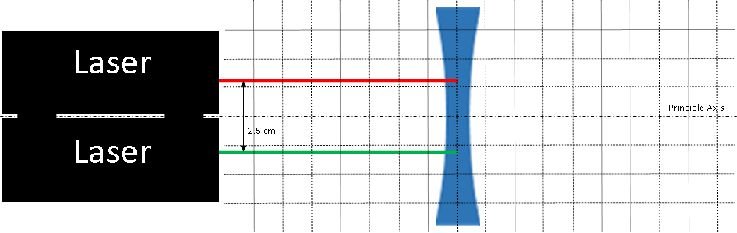
Draw the path of the laser as it refracts through the lens below. This is known as a ray diagram.
Focal Length:
Concave f₁ = __________mm

Images from Concave Lenses: Unlike convex lenses, concave lenses form only virtual images as they bend the light away from a real focus (diverging lens).

Locating images through ray tracing.
We can locate the image of an object as it pertains to the lens by following three rules (see the figure below)
- A ray coming from the image that is parallel to the principle axis of the lens will pass through the focal point on the same side of the lens (see ray 1 in figure).
- A ray coming from the image that passes through the focal point on the opposite side of the lens will be parallel to the principle axis on the same side of the lens as the image (see ray 2 in figure).
- A ray coming from the image that passes through the center of the lens will not experience any change in direction (see ray 3 in figure).

The location of the image is where all three of the rays converge. The size, orientation, and location of the image can be determined from this point (see the figure below).

In the area below, create a scale drawing that shows the location, size, and orientation of the image that is 1.5cm tall and 15cm away for the 100 mm focal length concave lens (use the receipt paper if you need to).
Example:
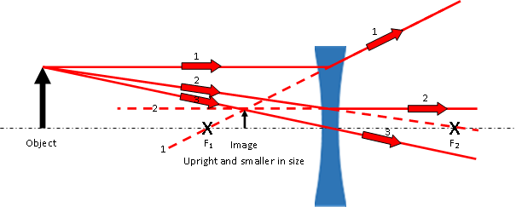
Determine the height of the image (show all work below).

Constructing a Galilean Refracting Telescope
Research the construction of a Galilean refracting telescope. Using the 300mm convex lens and the 100mm concave lens determine which lens needs to be the objective, which lens needs to be the eyepiece, and how far apart to place them.

Objective lens focal length = _______mm
Eyepiece lens focal length = _______mm
Distance between lenses = _______mm

- What is the difference in optical design between a traditional telescope and a Galilean telescope?
________________________________________________________________________________________________________________________________________________________________________________________________________________________________________________________________________________________________________________________________________________________________________

- Place the lenses in the optical tube assembly at the proper distances and assemble the tube by carefully placing the second half on top and securing it with the end stops.

- Observe an object that is at infinite focus or far away. NEVER point the spotting scope towards the sun, never look at the sun with the spotting scope. If the object is not in perfect focus you can make small adjustments with the position of the eyepiece with respect to the objective.

- Describe the image of the object, is it inverted, are there any optical defects or distortions, and how large is the object?
Investigate optical image aberrations to help answer the question: https://micro.magnet.fsu.edu/primer/anatomy/aberrationhome.html
________________________________________________________________________________________________________________________________________________________________________________________________________________________________________________________________________________________________________________________________________________________________________
________________________________________________________________________________________________________________________________________________________________________________________________________________________________________________________________________________________________________________________________________________________________________

- Is the image upright or inverted? _________________________________________________________

- How many times larger is the image than the object (what is the magnification of the image)?
Show all work and/or reasoning for your solution below.

Observe what happens to the magnification of the image when the objective focal length and eyepiece focal length is changed. Observe an object on the far wall and continue to observe that same object throughout the completion of this table.

Objective Focal Length | Eyepiece Focal Length | Telescope Focal Length (calculate this) | Observations on Magnification (did it get larger, smaller, etc..)
300mm Convex | 100mm Concave | 200mm | This is your baseline (compare all other observations to this one)
200mm Convex | 100mm Concave
500mm Convex | 100mm Concave
300mm Convex | 200mm Concave

Question:

What is the minimum objective focal length required to optically resolve the license plate on an oncoming car that 1,000 meters away using the image sensor on your cell phone at prime focus? Explain the reasoning to your solution below.

Note:
The objective lens on a telescope creates a real image, just like how a camera lens creates a real image on a film (or a CCD/CMOS sensor using current technology).

If you place your eye where this real image is, at the prime focus or objective focus of a telescope, you will not see an image. The reason why is because your eye is another optical system trying to create a real image. Your eye focuses an image onto an area on the back of your eye called the retina (see diagram below). It cannot focus a real image created by objective lens. Your eye requires a virtual image to focus a real image on the retina. The eyepiece creates a virtual image that your eye can focus into a real image.

The eyepiece in a lens system creates a virtual image that your eye can focus on.

Solution:

- Once you have solved for the minimum focal length, choose a lens that satisfies the minimum focal length requirement.

- Place the lens in the optical tube assembly at the proper distance from an end stop and assemble the tube by carefully placing the second half on top and securing it with the end stops.

- Place a piece of tissue paper over the end and point the lens in the direction of something far away and bright (never point it directly at the sun).

What do you see on the tissue paper? Why?
________________________________________________________________________________________________________________________________________________________________________________________________________________________________________________________________________________________________________________________________________________________________________
________________________________________________________________________________________________________________________________________________________________________________________________________________________________________________________________________________________________________________________________________________________________________
________________________________________________________________________________________________________________________________________________________________________________________________________________________________________________________________________________________________________________________________________________________________________
________________________________________________________________________________________________________________________________________________________________________________________________________________________________________________________________________________________________________________________________________________________________________
________________________________________________________________________________________________________________________________________________________________________________________________________________________________________________________________________________________________________________________________________________________________________
________________________________________________________________________________________________________________________________________________________________________________________________________________________________________________________________________________________________________________________________________________________________________

